Date:
Upper Heavy Work

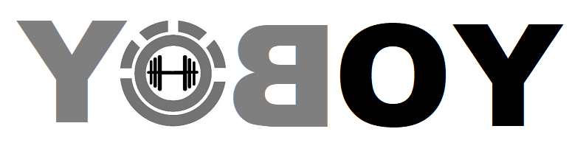
Chest
  Exercise
  REPS | Weight | Minutes Between Sets
  8 |  | 1
  6 |  | 1
  4 |  | 1
  4 |  | 1
  8 |  | 0
  8 |  | 2
Shoulders
  8 |  | 1
  6 |  | 1
  4 |  | 1
  4 |  | 1
  8 |  | 0
  8 |  | 2
Back
  8 |  | 1
  6 |  | 1
  4 |  | 1
  4 |  | 1
  8 |  | 0
  8 |  | 2
Triceps
  8 |  | 1
  6 |  | 1
  4 |  | 1
  4 |  | 1
  8 |  | 0
  8 |  | 2
Biceps
  8 |  | 1
  6 |  | 1
  4 |  | 1
  4 |  | 1
  8 |  | 0
  8 |  | 2

*Notes
Date:
Upper Heavy Work

Sample Exercise Log:
Chest
  Exercise
  Smith Machine Barbell Bench Press
  Smith Machine Barbell Bench Press
  Smith Machine Barbell Bench Press
  Smith Machine Barbell Bench Press
  Smith Machine Barbell Bench Press
  Incline Dumbell Press
  REPS | Weight | Minutes Between Sets
  8 |  | 1
  6 |  | 1
  4 |  | 1
  4 |  | 1
  8 |  | 0
  8 |  | 2
Shoulders
  Smith Machine Overhead Press
  Smith Machine Overhead Press
  Smith Machine Overhead Press
  Smith Machine Overhead Press
  Smith Machine Overhead Press
  Dumbell Lat Raises
  8 |  | 1
  6 |  | 1
  4 |  | 1
  4 |  | 1
  8 |  | 0
  8 |  | 2
Back
  Assisted Pullup Machine
  Assisted Pullup Machine
  Assisted Pullup Machine
  Assisted Pullup Machine
  Assisted Pullup Machine
  Bent Over Barbell Row
  8 |  | 1
  6 |  | 1
  4 |  | 1
  4 |  | 1
  8 |  | 0
  8 |  | 2
Triceps
  Triceps French Press
  Triceps French Press
  Triceps French Press
  Triceps French Press
  Triceps French Press
  Triceps Machine Pressdown
  8 |  | 1
  6 |  | 1
  4 |  | 1
  4 |  | 1
  8 |  | 0
  8 |  | 2
Biceps
  Machine Dumbell Curls
  Machine Dumbell Curls
  Machine Dumbell Curls
  Machine Dumbell Curls
  Machine Dumbell Curls
  Barbell Curl
  8 |  | 1
  6 |  | 1
  4 |  | 1
  4 |  | 1
  8 |  | 0
  8 |  | 2

*Notes Heavy Overload principle here. Even if need to focus on assistance or negative reps you want to be lifting as heavy as possible with GOOD FORM. Explosive contractions. Think power lift. 1Second down 1 second up.

