Date:
Upper Light Work

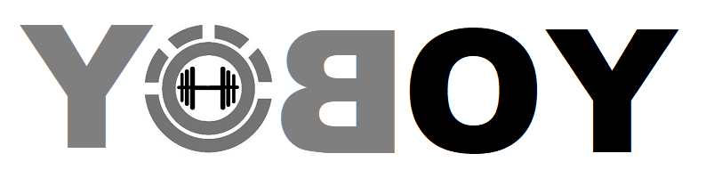
Chest
  Exercise
  REPS | Weight | Minutes Between Sets
  12 |  | 1
  10 |  | 1
  8 |  | 1
  8 |  | 1
  12 |  | 0
  12 |  | 2
Shoulders
  12 |  | 1
  10 |  | 1
  8 |  | 1
  8 |  | 1
  12 |  | 0
  12 |  | 2
Back
  12 |  | 1
  10 |  | 1
  8 |  | 1
  8 |  | 1
  12 |  | 0
  12 |  | 2
Triceps
  12 |  | 1
  10 |  | 1
  8 |  | 1
  8 |  | 1
  12 |  | 0
  12 |  | 2
Biceps
  12 |  | 1
  10 |  | 1
  8 |  | 1
  8 |  | 1
  12 |  | 0
  12 |  | 2

*Notes
Sample Workout Gym:
Chest
  Exercise
  Machine Bench Press
  Machine Bench Press
  Machine Bench Press
  Machine Bench Press
  Machine Bench Press
  Machine Flye
  REPS | Weight | Minutes Between Sets
  12 |  | 1
  10 |  | 1
  8 |  | 1
  8 |  | 1
  12 |  | 0
  12 |  | 2
Shoulders
  Overhead Machine Press
  Overhead Machine Press
  Overhead Machine Press
  Overhead Machine Press
  Overhead Machine Press
  Dumbell Lat Raises
  12 |  | 1
  10 |  | 1
  8 |  | 1
  8 |  | 1
  12 |  | 0
  12 |  | 2
Back
  Machine Lat Pull Down
  Machine Lat Pull Down
  Machine Lat Pull Down
  Machine Lat Pull Down
  Machine Lat Pull Down
  Machine Back Row
  12 |  | 1
  10 |  | 1
  8 |  | 1
  8 |  | 1
  12 |  | 0
  12 |  | 2
Triceps
  Machine Rope Pressdown
  Machine Rope Pressdown
  Machine Rope Pressdown
  Machine Rope Pressdown
  Machine Rope Pressdown
  Overhead Dumblee Extension
  12 |  | 1
  10 |  | 1
  8 |  | 1
  8 |  | 1
  12 |  | 0
  12 |  | 2
Biceps
  Machine Stack Curl
  Machine Stack Curl
  Machine Stack Curl
  Machine Stack Curl
  Machine Stack Curl
  Dumbell Curls
  12 |  | 1
  10 |  | 1
  8 |  | 1
  8 |  | 1
  12 |  | 0
  12 |  | 2

*Notes * Focus on Form, slow and controlled 2 seconds up:2 seconds down. Ring out the contraction at the peak and flex hard. Never relax tension on contraction.

