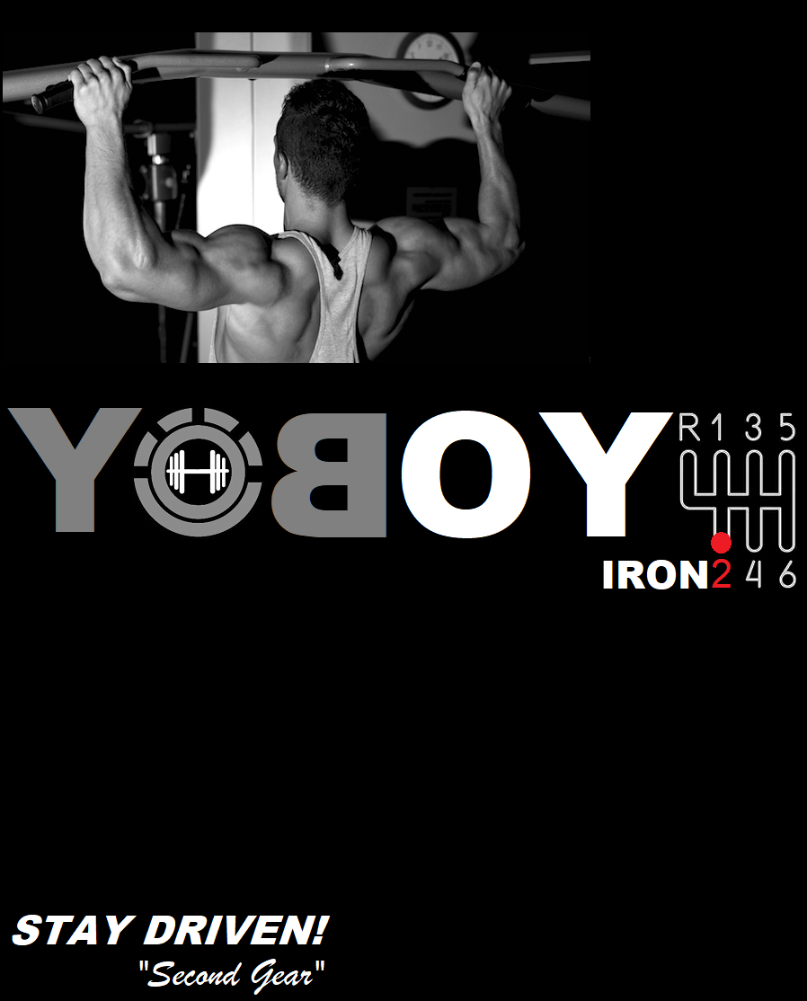

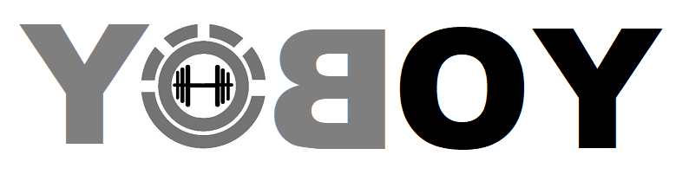IRON²
STRENGTH & MUSCLE BUILDING PROGRAM

IRON² is a program designed as a foundation to help you build muscle and gain strength through a 5 cycle conditioning curriculum, nutrition plan, and simple tips to help boost your progress. The program is designed to get you results you are looking for in 8 weeks time. So YOBOY!, What are you waiting for?
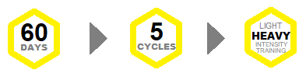
GETTING STARTED:
KEYS TO BOOST PROGRESS
 | Decide & Commit. Refocus your mentality before going into this program.
  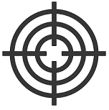 | - Keep an image of your goal in plain sight daily  - Answer “Who do I become to reach my goal, and what motivates me to reach it”.  - Learn to become comfortable with uncomfortable. To have what you’ve never had you have to do what you’ve never done. We give you the map. Follow it.

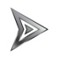 | Apply the “Core 4; Elements into your Training and Nutrition.  ( *Not required for success but will accelerate your results)  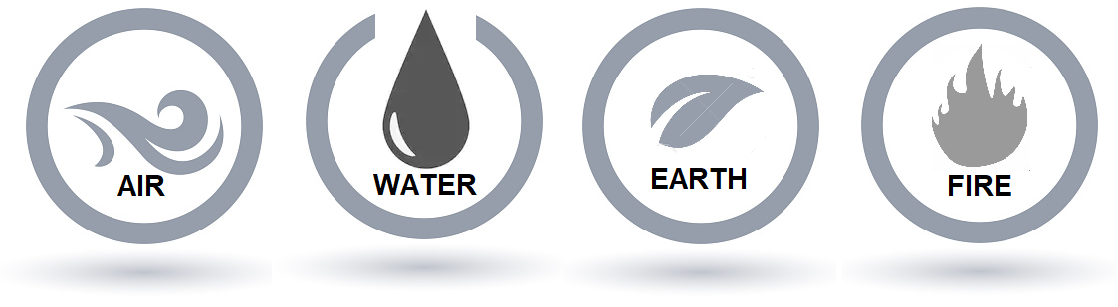

TRAINING CALENDAR 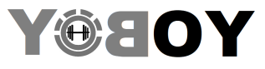IRON²
Each 12 day training cycle consists of 8 workouts and 4 rest days. Within’ each cycle includes 1 light workout and 2 heavy workout for each body part, totaling 2 workouts each per bodypart per cycle. NOTE: On REST DAYS,ACTIVE REST is recommended. This can include any low impact activity you prefer.
^{A Shoulders/Traps} | ^{B Back/Biceps/Forearms} | ^{C Chest/Triceps} | ^{D Legs}

